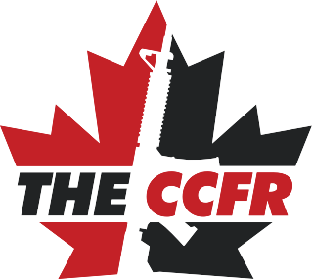

CUSTOM INSURANCE SOLUTIONS

for your interest in allowing the CCFR to Provide your club insurance!

Membership with the CCFR – this includes our $5,000,000 in liability insurance for all club members (coverage includes hunting, fishing and lawful firearms usage). Members will receive CCFR membership cards, have full voting privileges for director elections and corporate policy amendments, and most importantly will be contributing to the advocacy work that the CCFR does on behalf of all Canadian firearm owners. The cost is $40/member/year and a $60/year club membership.

Each club has its own priorities, and we understand that many clubs want to keep their membership fees as low as possible. We hope that you will consider partnering with us, especially in view of the hostility lawful firearm owners are currently facing. For administrative purposes we will require a list of your membership including a mailing address and either an email or phone number to contact members with in the event of an insurance claim.

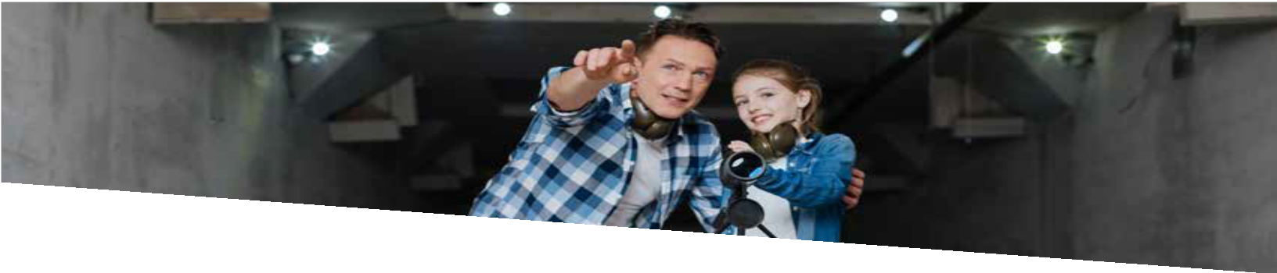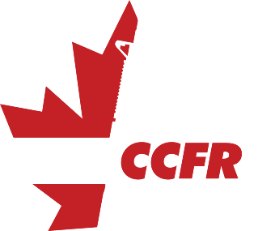
CUSTOM INSURANCE SOLUTIONS

CCFR Insurance Coverage Summary
(includes all family members)
- $5,000,000 Personal Liability per claim
with no annual limit restriction
- Members are covered should they cause a third-party bodily injury or third-party property damage while engaged in any recreational shooting, archery, or fishing activity.
- Coverage is worldwide - some policies only cover you at your home range (legal action must take place in Canada or the USA)
- This insurance policy shall not apply to:
  - Business activities
  - Equine related activities
  - Fireworks / pyrotechnics activities
INDIVIDUAL MEMBER COVERAGE
For more information on our insurance program and all other insurance related questions, please contact our broker Zach Schwingenschloegl at CapriCMW Insurance:
Direct 250-869-3987
- $5,000,000 Commercial General Liability coverage per claim with no annual limit restriction (a minimum of $2 million is mandated by the Firearms Act)
- Primary coverage (meaning the policy takes effect immediately). This includes AGM’s, open houses, club-hosted competitions or other any event normal and usual to a CCFR Club, whether on club property or not.
- $5,000,000 Directors & Officers/Wrongful Acts Liability for the club directors and officers at no additional cost.
- Guests are covered. Some form of logbook or attendance sheet shall be collected by the club or insured member. This includes all sanctioned club events or simply accompanying a club member to the range. This reduces barriers to introducing new shooters to the sport.

Note: To be eligible for the Club insurance, the club must be affiliated with the Canadian Coalition for Firearm Rights. An affiliated club is one where all members who are full members of the CCFR.
Club Coverage
Toll Free 1-800 670-1877 Ext 3987
Email zschwing@capricmw.ca
Fax 250-860-1213
For more information from the CCFR contact Tracey Wilson: Direct: 613-816-0997 clubs@firearmrights.ca

